**PROJECT REPORT**

As there are two types of call one is “Normal Call” and another one is “Emergency call”. Our project is based on the emergency mode.

We all know when there is no network connectivity our mobile shows “emergency calls only” on the top of our mobile and sometime it shows the “no service”. What it actually means is that when our mobile shows the emergency call only it means that there is no network of that SIM operator but having some network of another operators. By means of which an emergency calls is established.

1. **Flow of normal call.**

when a person makes a phone call the “mobile station firstly connect to the BTS by means of the “Um air interface”. Then BTS transfer the connection request to the BSC(base station controller) by means of Abis interface. BSC allocates a channel to the call and after allocating the channel transfer the request to the MSC(mobile station controller) by means of the A interface . Every operation like AUC (authentication), EIR( Equipment Identity Register ),HLR(home location register), VLR(visitor location register). After processing on these steps the call finally transfer to the G-MSC (Gateway mobile station controller). Then the G-MSC transfers the call to the PSTN( public switched telephone network) as shown in fig.1. 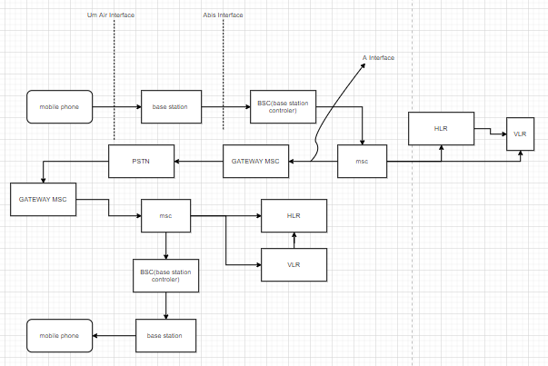 In fig. 1 Normal call flow.

1. **Protocols**

There are several protocols working in the flow of a call. But we are working on the MM protocol. Complete study about all the protocols------[2]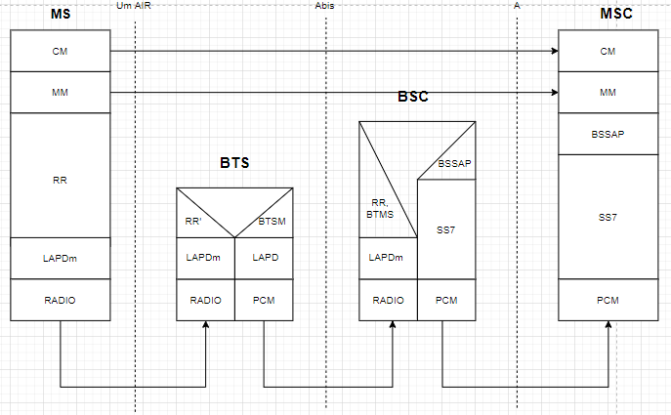

Our project is totally depend upon the MM protocol .

* 1. **DETAILED STUDY ABOUT MM PROTOCOL FOR EMERGENCY CALL SETUP.**

When we make an emergency call a “CM REQUEST” is being send to the network from our mobile station by means of which our network identify what type of call it is. “CM REQUEST” consist of many parts of messages as shown in the fig.3. -------[3]

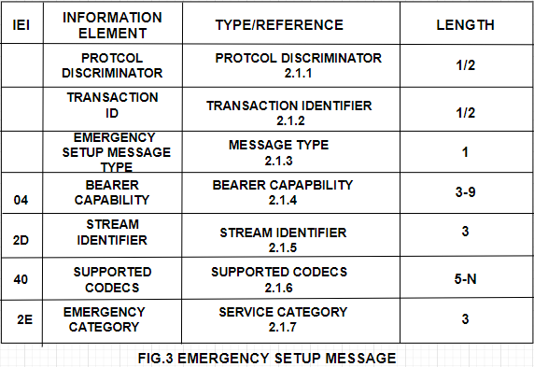

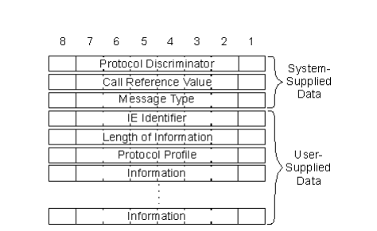

* + 1. **PROTOCOL DESCRIMINATOR**

Prototcol discriminator discriminates between the two protocols by which the network side comes to knows that from which protocol this message was generated for example.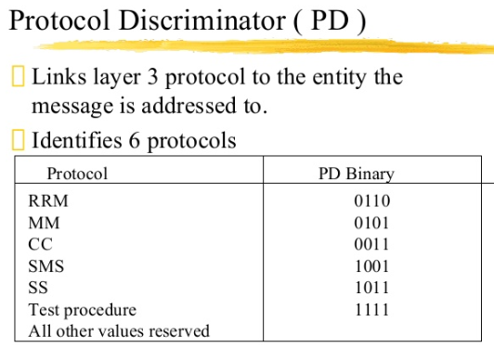

**2.1.1.1: Frame structure for protocol discriminator.**

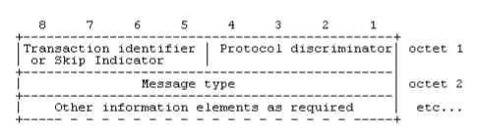

* + 1. **TRANSACTION IDENTIFIER**



In the above frame structure 5-8 bit consist of transaction identifier or skip indicator for every type of MOBILITY MANAGEMENT MESSAGE.When any mobile station wants to send the CM REQUEST, LOCATION UPDAATE REQUEST type of request or at the time of receiving these type of request messge from the network the skip indicator are used these type of bits format..

* Any skip indicator received with any other no rather than 0000bits is being ignored by the network and mobile station because the message with skip indicator other than 0000 is considered as error.
* 5-7 bit is for TI and 8bit of first octet is for TI flag.
* If the message of transaction is initiated from the user side then the flag is ‘0’ and ‘1’for others.
* Hence the TI flag identifies who allocated the TI value for this transaction and the only purpose of the TI flag is to resolve simultaneous attempts to allocate the same TI value.

**2.1.3.1: Frame for transaction identifier**

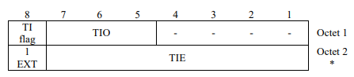

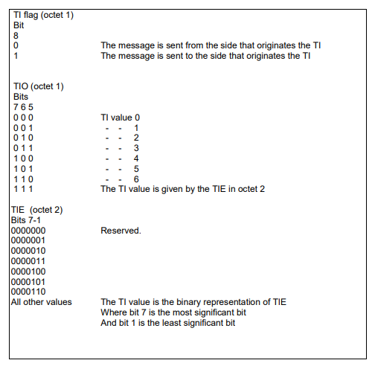

* + 1. **MESSAGE TYPE**

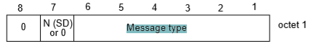

* Here bit 8 bit for the connection to core network earlier than the R99 is assigned as ‘0’ and bit 7 is reserved for the sequence number in messages sent from the mobile station. The messages that are sent by the network side is coded as ‘0’ for both 7 and 8 bits.
* The connection to the core network of R’99 and later, bits 7 and 8 are reserved for sending the sequenced number in messages from the mobile station and the messages sent from the network side the 7 or 8 bit is coded as ‘0’.

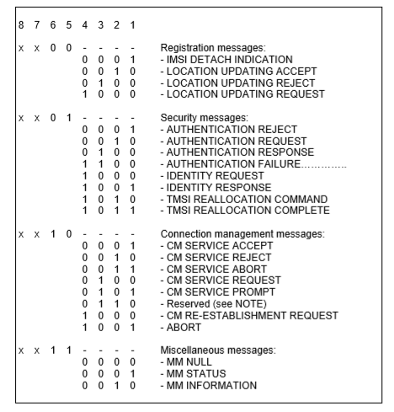 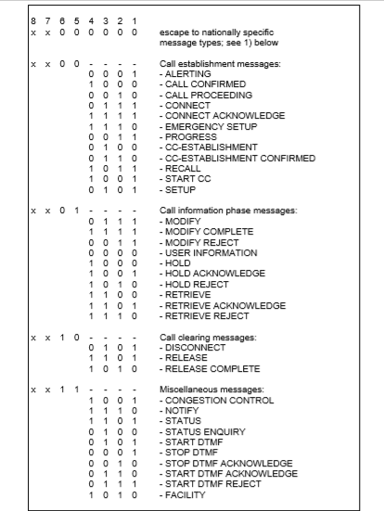

* + 1. **BEARER CAPABILITY**

The purpose of the bearer capability information element is to describe a bearer service. The use of the bearer capability information element in relation to compatibility checking is described in annex B.

The bearer capability has minimum length of 3 octet and maximum length of 16 octet. Bearer capability frame structure is

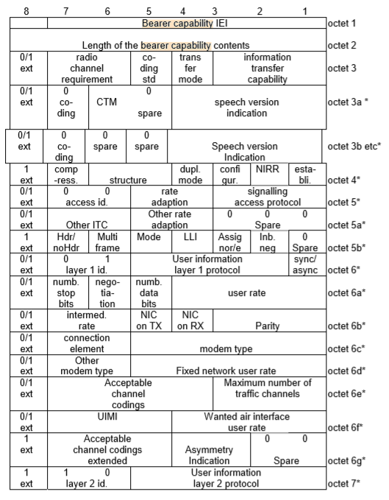

Mobile stations that are not supporting the A/Gb mode and GERAN Iu mode coded ‘0’ for the following:

* Maximum number of traffic channels (octet 6e, bits 1-3)
* Acceptable Channel coding(s) (octet 6e, bits 4, 5 and 7)
  + 1. **STREAM IDENTIFIER**

The purpose of the stream identifier (SI) information element is to associate a particular call with a Radio Access Bearer (RAB), and to identify whether a new traffic channel shall be assigned within the interface controlled by these signalling procedures. The SI value indicated in the CC protocol shall be sent in the RAB setup message. And mobile station is informed the relationship between the call and the RAB.

Frame structure for stream identifier is :

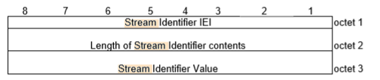

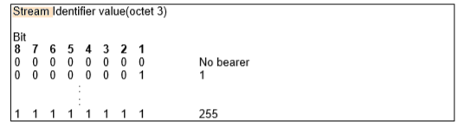

* + 1. **SUPPORTED CODEC LIST**
    2. **SERVICE CATEGORY**

The purpose of the Service category information element is to provide the network with information about services invoked by the user equipment.

Service category is a type 4 service and having minimum 3 octets.

Frame format for the service category is 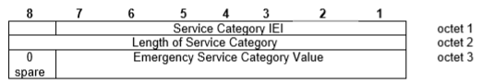

Bit code stack for this is:

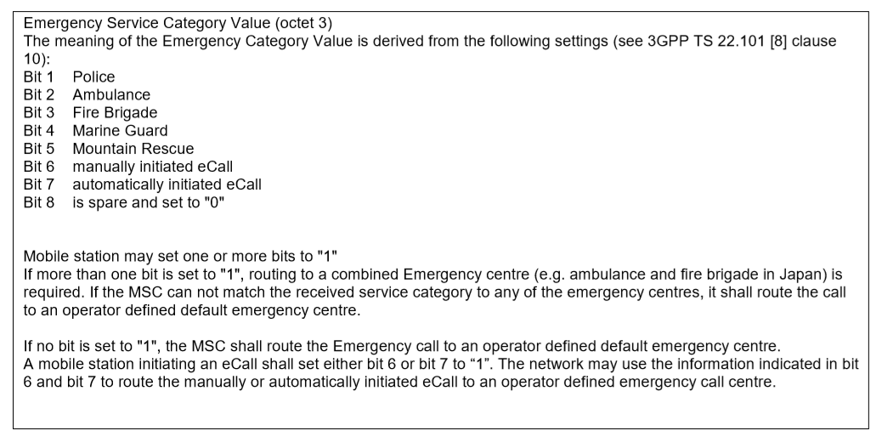

**REFERENCES**

[1]<https://www.arib.or.jp/english/html/overview/doc/STD-T63v9_60/5_Appendix/R99/24/24008-3k0.pdf>.

[2] <https://www.tutorialspoint.com/gsm/gsm_protocol_stack.htm>

[3] <https://www.arib.or.jp/english/html/overview/doc/STD-T63v9_60/5_Appendix/R99/24/24008-3k0.pdf>

[4] 3GPP TS 24.007: "Digital cellular telecommunications system (Phase 2+); Mobile radio interface signalling layer 3 General aspects".